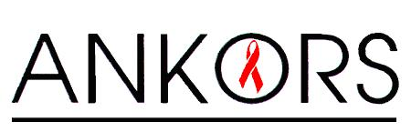
APPLICATION FORM: VOLUNTEERING AT FESTIVALS WITH ANKORS HARM REDUCTION
PLEASE EMAIL THIS FORM COMPLETED TO CHLOE / hrankors@gmail.com or fax it to 250505 5507
Applicant Name:
Email:
Phone:
Application Date:

- What does Harm Reduction mean to you?

- What are your experiences with Harm Reduction(volunteer, personal, work)?

- Please explain your knowledge around the different drugs and sexual health

- What is your experience with drug checking?

- What areas are you comfortable working in? (PLEASE CHECK)
- REAGENT TESTING
- INFO TABLE (sexual health, drug info, safer use, harm reduction supplies)
- OTHER DUTIES INCLUDE INTAKE and harm reduction education
- AND GENERAL FLOATER

- What training do you feel like you need?

